Greetings
Form Inside and Outside Circles
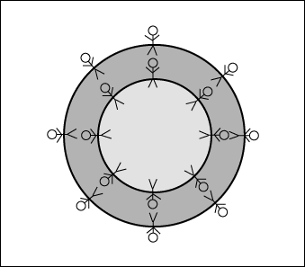
- Practice one, then move on to a new person.
Topic | Phrase
Introduce self | - Adults do it. Students don’t… It’s a powerful tool. Sets you up as friendly, and slightly above them. They’ll listen.  - Hello my name is _________, what’s yours? (Pause). Nice to meet you ________.
Greet and question | - Hi, I’m _____. What’s your name? (pause) What school did you come from?
 | - Hi, I’m _____. What’s your name? (pause) Which class did you come from?
Common Ground | - Homework, weather, lack of sleep
 | - Cool teachers, fun clubs, TV shows, games, on-line whatever…
Looking around the room | - What do you think of the font on the quotation? It’s horrible. Hi, my name’s _____.
 | - You know, they replaced the floor in here last year, I really like it. What do you think?
Observe them and comment | - Is that your backpack? I like the colour. Where did you get it?
 | - Is that your backpack? It looks heavy. Do you have a lot of textbooks this year?

Conservations with strangers
- Introduce
- Question – Get their responses – Cheery continuation… Repeat

- Try to find a common ground – TV show, movie, twitter feed, computer game, YouTube channel, Wattpad author (whatever) you both like. Then you can go on and on about it.
Try with MD partner. Boy silent. Then girl.

