Circles R Us 2.0 – With a Form

- Open your Circles R Us spreadsheet – these directions will only work for 2013 so be careful about the version.
- First, turn on the developer ribbon. To do this, go to the File Menu and pick Options.
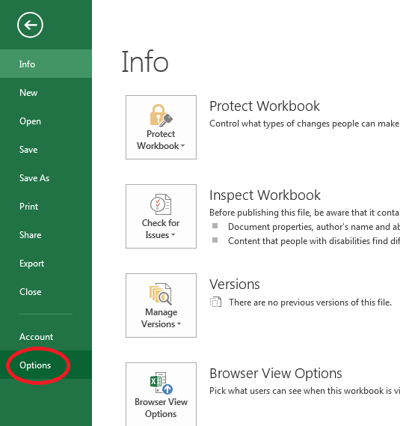
- Click on the Customize Ribbon option, then turn on the Developer tab (it is currently off).
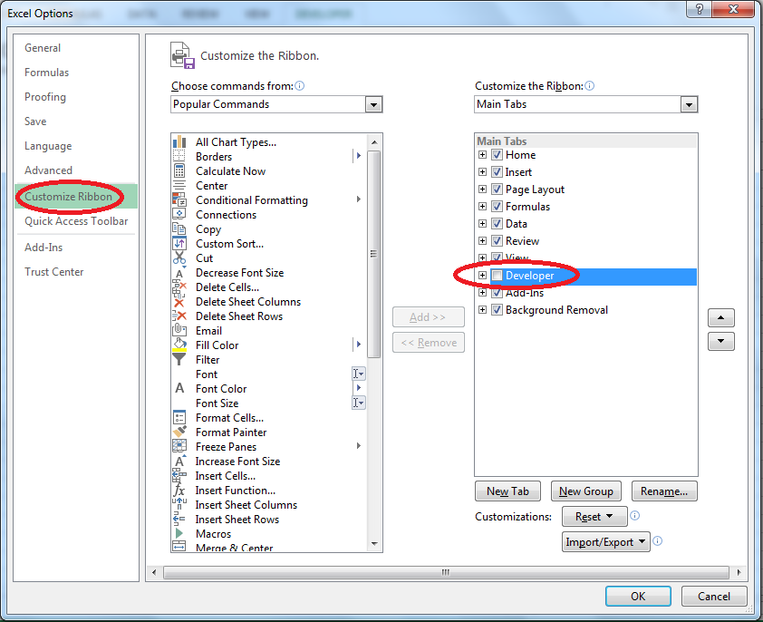
- The Developer tab will appear:
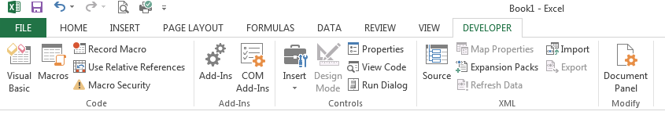

- Click on View Code:
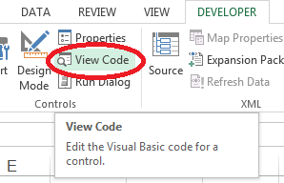

- You will get the Visual Basic Editor:
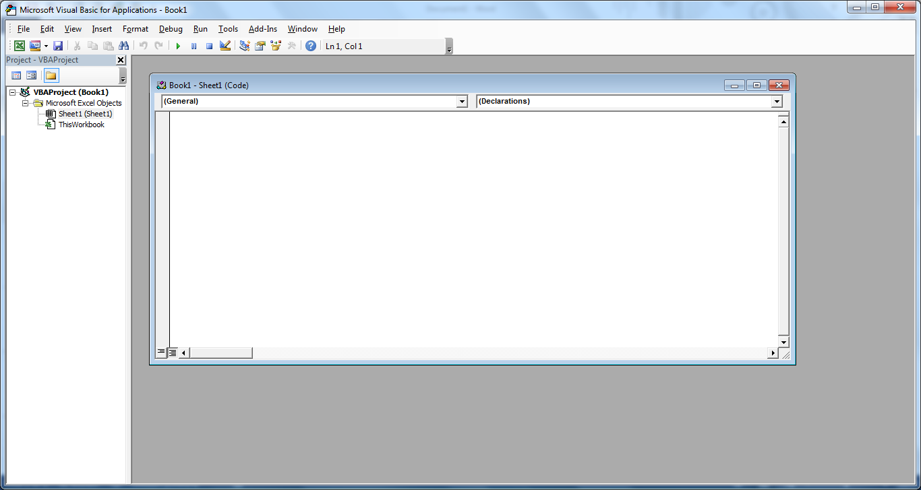

- Choose to Insert a user form:
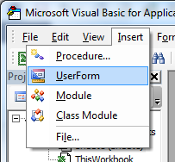
- Also choose to view the proprieties window. View → Properties Window
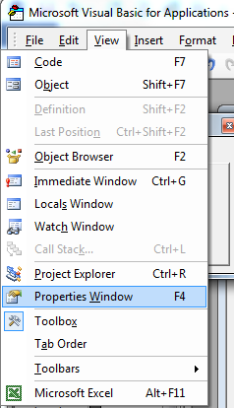
- On the user form, add a TextBox (ab| button) and a Label (A button). You will need to click on the appropriate control on the Toolbox and drag it on the form.
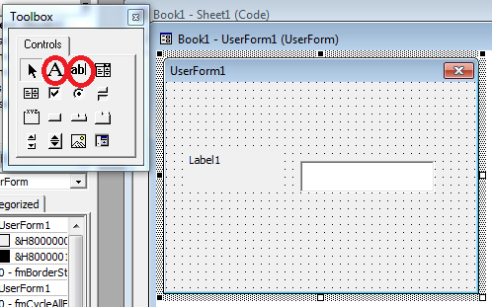
- To change the value of the Label from Label1 to something nicer, you need to select the label and then change it’s properties in the properties window.
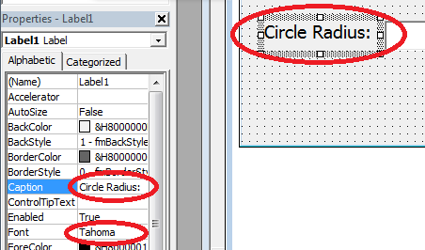

- Finish making the form:
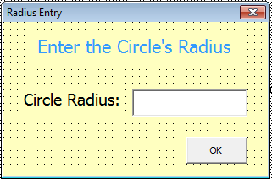 | - Make sure the title bar changes to “Radius Entry”  - Make a title, “Enter the Circle’s Radius” and change the colour of the Font.  - Add an “OK” button, it is a command button.  - Change the background colour of the title, label and form.  - Resize the form nicely.

- If you double click on the OK button, this appears. Make sure it says CommandButton1. If it does not, select it. It MUST be in the CommandButton1 section.
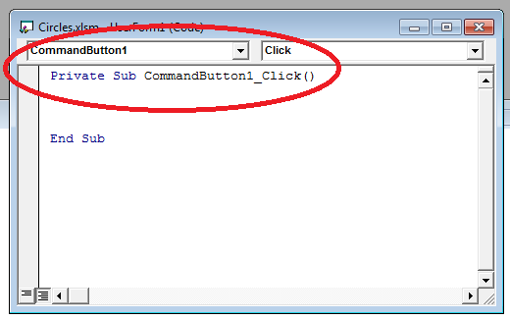

- Add in this code:

Private Sub CommandButton1_Click()
Dim rad As Double
rad = TextBox1.Text
TextBox1.Text = ""
Range("B3").Select
ActiveCell.FormulaR1C1 = rad
UserForm1.Hide
End Sub

- Add in the showForm sub to the other functions that you wrote previously. They will be located under module1.
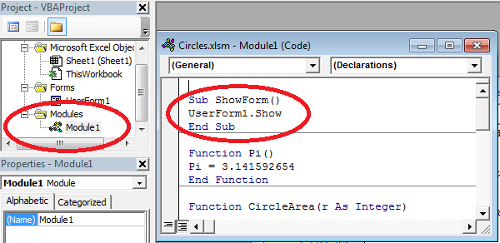

Sub ShowForm()
UserForm1.Show
End Sub

- Go back to the spreadsheet. Add a button using the Developer Tab, Insert, Button.
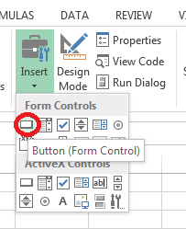

- Click on the form and create a button of the correct size, the following dialog will appear. Select your show form sub:
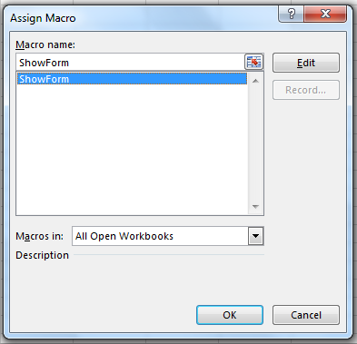
- Rename your button on the screen.
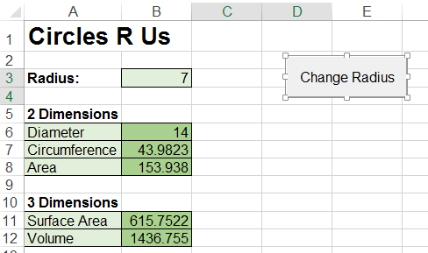

- Test your program. When you click on the button, your dialog box should appear, enter the number into the cell and the formulas should adjust.
